Max Quest Tournament 2.0

Software Requirements Specification
Version No.1
Status: draft
Date of SRS creation – Nov 12

Table of contents
1. Introduction 4
1.1 Purpose 4
1.2 Acronyms 4
1.3 Document Conventions 4
2. Overall Description 5
2.1 Product Perspective 5
2.2 Product Functions 5
2.2.1 General 5
2.2.2 Casino Manager functionality 6
2.2.3 Casino Manager Network Tournament Promo concept 6
2.2.4 Reports 7
2.2.5 Entering the Network Tournament flow 8
2.2.6 New leaderboard display format 12

Revision History
Name | Date | Reason For Changes | Version | Date of Approval
< Author’s Name> | <Date of Revision> | <Description of Made Changes> | <Version No.> | <Date of Approval>

Introduction

Purpose
This specification presents the requirements for the 2nd phase of the MQ Tournament’s development.

Acronyms
SRS – Software Requirements Specification
CM – Casino Manager
BSG – BetSoft Gaming
EC – External Client
MQ – Max Quest
TOR – Tournament casino chips
T&C – Terms and conditions

Document Conventions
For tracking the changes mark them in the document with color (changes, additions) or cross them (deleting).

Overall Description

Product Perspective
This specification introduces a new concept - Network tournaments.

Product Functions

2.2.1 General
Network tournaments are multi-cluster tournaments that will be hosted by BSG. Network tournaments are expected to function in the same way as current local tournaments. An exception is the player registration process, which must support players from different clusters.

Network tournaments can be just a one type:
- Freeroll Tournaments are free tournaments that are available to all players - no down payment required.

At the end of each tournament (at the end of each week, possibly in the future), all players take places in the standings according to the final score and receive a real cash prize depending on how the licensee has distributed the prize pool. Depending on the prize pool distribution, players who qualify to receive a prize will be receiving their respective prize manually (at the operator’s discretion). Note that the reward in the Network tournament only is a cash bonus for the 2nd phase.

There are two types of ranking players (configurable when creating a tournament in CM):
- By tournament balance. The player that has the largest balance at the end of the tournament wins the 1st prize. Tie - Breaker: Whoever wagered the most.
- By total wagering. The player that has wagered the most wins the 1st prize. Tie Breaker: Whoever has the largest total balance.

The uniqueness of the player's alias. To give the player a unique alias, the following scheme is proposed: each cluster will be assigned its own unique ID. The formula will be used to assign a name: playerAlias = clusterId + (playerNum * clusterCount), where clusterId – unique cluster Id, playerNum - player's serial number, clusterCount - number of clusters.
For example, cluster c2ss is assigned Id = 0. There are 6 clusters in total. The player enters the alias «Mike». He was the 1st player to choose this alias (note that players and clusters count down from 0). Then we get: playerAlias = 0 + (0 * 6) =Mike. If he was the second on c2ss cluster, who choose this alias, the alias will be displayed as follows: playerAlias = 0 + (1 * 6) =Mike#6. «#6» will automatically be assigned to the player's alias «Mike». The player will identify himself by this alias in the game client and leaderboard. And then all aliases will be assigned to players according to the same logic.
Note: If the tournament involves licensees belonging to the same cluster, then in this case cluster won't be assigned its own unique ID. Then the player's alias is checked for uniqueness within the cluster. And, if the alias is non-unique, then an error message should be displayed for the player and the need to choose a different alias.
Note that in the 2nd iteration it must be a multiplayer mode in each room. So, players will see each other's aliases.
Launching the Network Tournaments. The operator will launch online tournaments via following link: cwstartgamev2.do?gameId=X&mode=real&token={TOKEN}&bankId={BANKID}, where X is a separate ID for network tournaments.
The players will have the same alias throughout the tournament

2.2.2 Casino Manager functionality
Now the operator uses the section «Management - Promotion - Create MQ Tournament» to create local tournaments.
It is assumed that in order to create a network tournament, the BSG operator will create a tournament through the section «Create Network tournament» with presumably the following set of attributes:
- Name,
- Clusters (with the ability to select several clusters participating in the tournament),
- Subcasinos (with the ability to select several subcasinos),
- Banks (with the ability to select several banks),
- Game, / Games BSG should be able to select the MQS games that will participate in the Network Tournament. The selection would be done from CM. [Recommended Solution for InGame/InLobby : After Player selects their Event 1-4, they will be presented with a choice of MQS games to enter, Art Team will prepare example/assets upon Dev approval of the solution)
- Start Date, Start Time, End Date and End Time (min. tournament time – 1 hour, max. – 3 months),
- Starting balance,
- Currency (€),
- Prize pool distribution
  - Prize pool size,
  - Number of winners,
  - Last place win value,
- Ranking type (Tournament balance/ Wagering amount),
- Tournament type (freeroll),
- Tournament icon (selection from the list),
- Localization titles

2.2.3 Casino Manager Network Tournament Promo concept
TBC: in this section, it is necessary to clarify the possibility of combining Network tournaments of one landing page into one promo in the CM.

2.2.4 Reports
To control and receive global information about promo network tournaments, it is necessary to add reports to CM. In the section Reports & Statistic - Promotion - a report called Network Tournament List (for example).

Network Tournament List
This report displays all MQ network tournaments (active and completed).
The values in the Bet sum, Wins Sum, and Game Revenue columns are in TOR, not in the player's currency.
Attributes:
- Start Date
- Tournament Status
- Tournament ID,
- Tournament name,
- Participants counts,
- Bets Count,
- Bet Sum,
- Win Sum,
- Game revenue,
- Total Prize Pool

Network Tournament Details report
Report for viewing network tournament details. The report should be available from the Tournament List by transition from the Participants Count column. The values in the Bet sum, Wins Sum, Game Revenue and Current Balance columns are in tournament chips, not in the player's currency.

Attributes:
- External ID,
- Player name,
- Time joined tournament,
- Bet sum,
- Win sum,
- Game revenue,
- Current balance.
- Prize (This field is specific for every player. Thus, if player is NOT part of the winners, put zero)

Universal Leaderboard Winners
Report for viewing standings details. Attributes:
- Place,
- External ID,
- Score
- Currency (€),
- Prize,
- Prize (in player’s currency),
- Cluster, Subcasino,
- Bank, (What’s the difference between Bank and Bank ID?)
- Bank ID

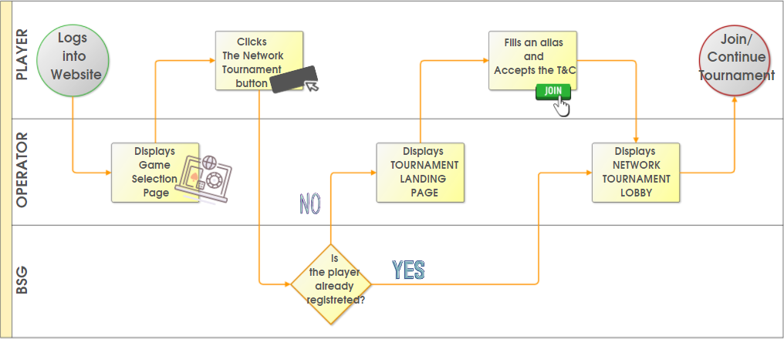
2.2.5 Entering the Network Tournament flow
Figure 1. Entering the Network Tournament BPMN diagram

Basic Flow: Entering the Network Tournament for non-registered player
Line | Player | Operator | BSG
1 | Logs into their respective operator website | Display the game selection page with buttons for various games including a button for starting «Network MQ Tournament»
2 | Clicks the button for starting «Network MQ Tournament» | Redirects player to a new window | Identifies by token that the player has not previously registered in the network tournaments
3 | The player fills in the required field and accepts the T&C | Display Tournament landing page (see below for details) with sigh-up form containing an input field for an alias and T&C
4 |  | Redirects player to the Network Tournament Lobby
Post condition: The loyal player will return to play for real version of MQ

Alternate Flow (AF₁): Entering the Network tournament for already registered players
If at line 2 in Basic Flow, the BSG identifies that the player already registered in the network tournaments, then:
Line | Player | Operator
1 |  | Redirects player to the Network Tournament Lobby
2 | Selects a tournament to continue playing or join a new one
The use case restarts at line 4 in Basic Flow

Tournament landing page has the following structure:

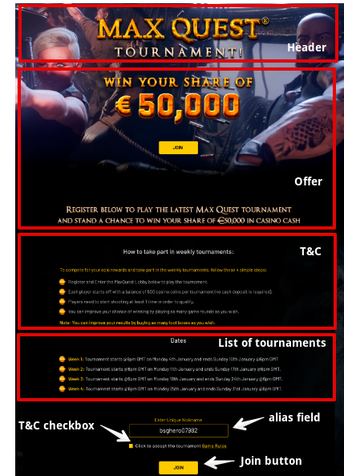
Figure 2. Network Tournament landing page

№ | Element | Description
1 | Header | Header with the «Max Quest» tournament logo and a picture
2 | Offer | Offer with «Join» button. The offer looks like a call to join the fight for a cash prize (WIN YOUR SHARE OF €50,000, where 50,000 is the total prize for the tournaments included in the promo.). The «Join» button should scroll down to the registration area of the landing page.
3 | T&C | How to take part in weekly tournaments:  To complete for your epic rewards and take part in the weekly tournaments, follow these 4 simple steps:  - Register and Enter the MaxQuest Lobby below to play the tournament.  - Each player starts off with a balance of XXX casino coins per tournament (no cash deposit is required).  - Players need to start shooting at least 1 time in order to qualify.  - You can improve your chance of winning by playing as many game rounds as you wish.  Note: You can improve your chance of winning by buying as many loot boxes as you wish
4 | List of tournaments | List of tournaments with start and end dates.
5 | Alias field | Player can use only Latin letters and numbers when entering his nickname
6 | T&C acceptance | « Click to accept the tournament Game Rules». Player must click on the checkbox. Clicking the Game Rules directs player on the popup window with Tournaments details and Prize Pool. See below for details.
7 | «Join» button | Directs player to the Network Tournament lobby. Note that Network tournament lobby is accessible only for registered players.

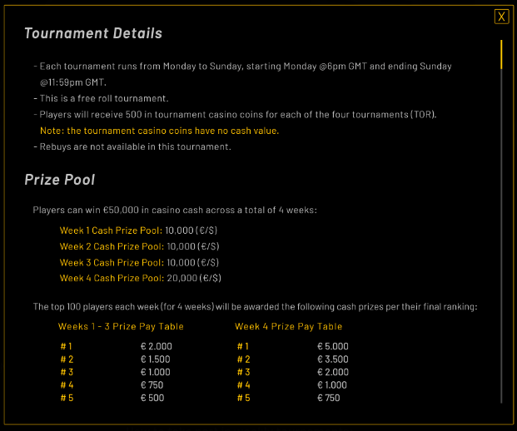

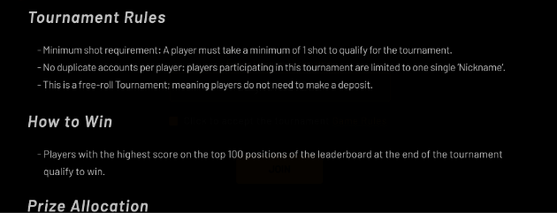

Figure 3. Pop-up window for Game Rules

№ | Element | Description
1 | Tournament Details | - Each tournament runs from DAY_OF_WEEK to DAY_OF_WEEK, starting START_DATETIME and ending END_DATETIME.  - This is the Free-roll tournament  - Players will receive XXX in tournament casino coins for each of the four tournaments (TOR)  Note: The tournament casino coins have no cash value  - Rebuys are not available at this moment
2 | Prize Pool | Prize pool distribution rules
3 | Tournament rules | - Minimum shot requirement: A player must take a minimum of 1 shot to qualify for the tournament  - No duplicate accounts per player: players participating in this tournament are limited to one single «Nickname»  - This is a free-roll Tournament; meaning players do not need to make a deposit
4 | How to win | - Players with the highest score on the top 100 positions of the leaderboard at the end of the tournament qualify to win
5 | Prize allocation

If something went wrong in the system, the following window should be displayed:
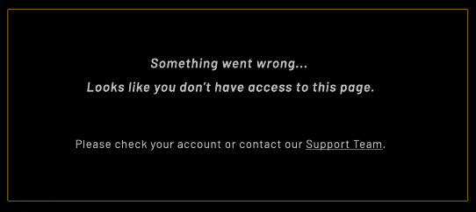
Figure 4. Error pop-up window

2.2.6 New leaderboard display format
The order of displaying players in the standings has changed:
- Only 10 winners will always be displayed, regardless of the number of prize places in the tournament,
- A new joining player will always see his nickname on line 11. If he enters the top 10, his nickname will be duplicated on line 11 and on the line corresponding to his prize.
- Scroll bar removed from the table,
- The position that is entitled to a cash prize highlighted in orange.
